Chapter 8, Problem 77.

Draw the dual of the circuit in Fig. 8.121.

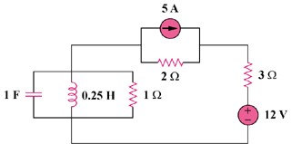

Figure 8.121
For Prob. 8.77.

